Understanding Your Local Sky Name: _______________________________________

In this lab, we will explore the apparent motion of stars in the sky, and the location of the star Polaris (the North Star) on the sky as viewed from different places on the Earth.

To discuss how “high” a star appears in the sky, astronomers define the altitude of a star as the angle it makes with the horizon. This elevation angle (shown for a couple examples in the diagram below) can go from 0 degrees (meaning it is on the horizon) to as high as 90 degrees (also known as overhead or zenith). We will investigate how the altitude of Polaris varies depending on an observer’s location on the Earth.

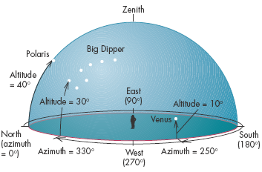

To simulate the night sky, we will be using the software Stellarium, which is free and easy to download/install. Go to the following link: https://stellarium.org/
And click on the platform you’re using (Windows/Mac/Linux etc.) to install Stellarium.

After you install and open Stellarium, you’ll immediately find yourself with a view of the sky as seen from a field at the date & time of your class.

Stellarium sets the starting location to be Paris, France, so you’ll need to change starting location to NYC.If you move the mouse around the screen, you’ll find two menu bars, one on the lower-left hand side of the screen, and another on the bottom of the screen. On the left-hand side menu, scroll over the options until you find location option. Click on this & a pop-up window appears with a world map. A red arrow shows your location as well as your latitude & longitude. On the right hand side of the world map is a list of locations in Stellarium. Type New York into the search box & a list of locations in New York State will appear in the list. Click on New York (sometimes it reads New York City, NY). Make sure the arrow changes position on the world map.
Write down the numbers in the ‘Latitude’ and ‘Longitude’ boxes for your location (NYC).

Ans-Latitude and longitude coordinates are: 40.730610, -73.935242

To make things easier to see near the horizon, you’ll want to switch the landscape to get rid of the houses and trees that show up by default. To do this, move the mouse to the left -hand side menu and select “Sky and Viewing Options”. In the window that opens, select “landscape”. There are a number of landscapes to choose from, but the “ocean” landscape will have the least number of obstructions (zero). Select this landscape and close the window.

On the bottom menu, scroll over the options until you find cardinal points (the “cross” symbol). Make sure this button is ‘on’ (lit up). This generates red-letter N(orth), S(outh), E(ast), W(est) superimposed on the landscape. It helps orient you when first using Stellarium.

5b Move the mouse so that you are looking north into the sky. Note that you can zoom in or out by turning the wheel on your mouse, or by using two fingers on a trackpad.
Use the fast forward button on the menu on the bottom of the screen to move time forward faster. The more you click this button, the faster time will progress. (If you want to pause things at any time, press “play” to return to a realistic time rate, which is close enough to pausing.) Look at the night sky as time progresses relatively quickly.

Write down how the stars appear to move? Sketch their motion if this helps with your description.
Ans-. The apparent star tracks are in fact not due to the stars moving, but to the rotational motion of the Earth. As the Earth rotates with an axis that is pointed in the direction of the North Star, stars appear to move from east to west in the sky. The Earth's rotation, everything in the sky seems to move together, turning once around us every 24 hours.

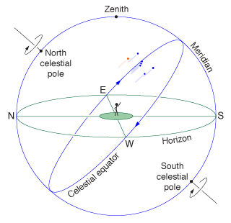

Do any stars not appear to move very much? Click on the star that appears to move the least. Some text will appear in the top left corner of the screen. One line reads Alt/AZ and gives you some numbers (degrees, minutes & seconds for both alt. & AZ.) For this lab, we only care about the second angle (after the “/” sign), which is the altitude. Write down the name of this star (it should be Polaris; if not, you’ve got the wrong star) and its altitude (just degrees is sufficient, we don’t need the minutes & seconds part).
Ans- If the pole's location is far enough above the horizon, some stars never set. They just keep spinning. If your geographical location happens to be close to the pole, most stars will be rotating around the pole and very few will rise and set.

How does the altitude of this star compare with the latitude of your location?
Ans- Altitude,” which is often called angular altitude, means the angle between the horizon and an object in the sky. In the northern hemisphere, the altitude of Polaris is equal to the latitude.
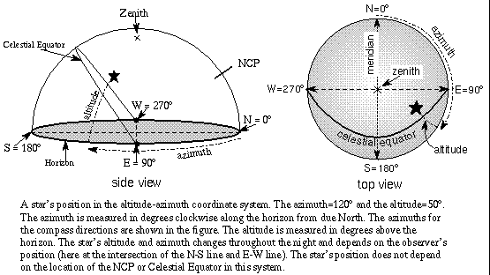

5c Use the menu on the left-hand side of the Stellarium screen to open the location finder window. It should show a red arrow pointing to the location of NYC on the world. In the search line, enter Kampala, Uganda.
Write down the Latitude and Longitude of Kampala.
Ans-The latitude of Kampala, Uganda is 0.347596, and the longitude is 32.582520. Kampala, Uganda is located at Uganda country in the Cities place category with the gps coordinates of 0° 20' 51.3456'' N and 32° 34' 57.0720'' E.

Look North from this location, as you just did for NYC. Fast forward time so that you observe the motion of the stars at night over several hours.
Write down how the stars appear to move? Sketch their motion if this helps with your description.
Ans-. The apparent star tracks are in fact not due to the stars moving, but to the rotational motion of the Earth. As the Earth rotates with an axis that is pointed in the direction of the North Star, stars appear to move from east to west in the sky. The Earth's rotation, everything in the sky seems to move together, turning once around us every 24 hours.

Do any stars not appear to move very much? Click on the star that appears to move the least (it should be Polaris again). If you are having trouble finding it, it might help to temporarily turn off the cardinal points, which might get in the way (the “cross” symbol on the bottom menu turns them on/off). Write down the name of this star and its altitude.

Ans- No, all the stars do not move in the sky. The Pole star is located above the axis of rotation of the Earth in the north direction. Thus, it appears stationary at a point in the sky, it does not move in the sky.
-Polar Star. With a bit of North Star Trigonometry it is possible to show a simple relation: Your Geographical Latitude = Height of North Star above horizon. So, if you live in, say, Paris at 48º North, Polaris will be 48º above the Northern horizon

How does the altitude of Polaris compare with the Latitude of Kampala?
Ans- at the Equator (0° of latitude), the North Star is on the horizon, making an angle of 0°. For any point between the Equator and the North Pole, latitude is obtained simply by measuring the altitude of Polaris: at 30°N the star is 30° above the horizon, at 63°N; it is 63° above the horizon, and so on.

Finally, let’s choose a location that is at very high northern latitude: Longyearbyen on the island of Svalbard, which is part of Norway. Open the location window and type in Svalbard; click on the location titled “Longyearbyen, Svalbard”. Write down its latitude and longitude.
Ans- 78.2232° N, 15.6267° E

Now find Polaris using the same method as before: look for the star that moves the least. (Hint: you will need to zoom out, and perhaps scroll up a bit, to find it.) Write down its altitude. How does the altitude of Polaris compare with the latitude of Svalbard?

- Ans- Coordinates | - 78°00′N 20°00′ECoordinates: 78°00′N 20°00′E
- Major islands | - Spitsbergen, Nordaustlandet, Edgeøya
- Area | - 64,029 km² (24,722 sq mi)
- Coastline | - 3,587 km (2,228.9 mi)
- Highest elevation | - 1,713 m (5,620 ft)
- Highest point | - Newtontoppen
- Administration
- Norway
- Largest settlement | - Longyearbyen (pop. 2060)
- Demographics
- Population | - 2600 (2007)
- Pop. density | - 0.04/km² (0.1/sq mi)

-Note that “altitude,” which is often called angular altitude, means the angle between the horizon and an object in the sky. In the northern hemisphere, the altitude of Polaris is equal to the latitude

Based on the pattern you have seen for these three locations, where in the world will Polaris have an altitude of 90 degrees? At what latitude will this occur, and what do we commonly call this location?
Ans- NORTH POLE .If you joined Santa last Christmas at the north pole (90 degrees latitude), you would have seen Polaris straight overhead and the celestial equator on your horizon. The point straight overhead on the celestial sphere for any observer is called the zenith and is always 90 degrees from the horizon.
It occurs between 90.0000° N, and 135.0000° W and commonly called North Pole

To test this, open the location window and enter this latitude and verify that Polaris is indeed at 90 degrees. (Again, you’ll have to zoom out and scroll up a bit to find it.) If it doesn’t match your prediction, check with your lab instructor before turning in the lab.

